**VISVESVARAYA TECHNOLOGICAL UNIVERSITY**

**“JnanaSangama”, Belgaum -590014, Karnataka.**



**PW-1 REPORT**

**on**

**BMS HOSTEL PORTAL**

***Submitted by***

**BHAVYASRI TAMMINANA (1BM20CS169)**

**UMANG GOEL (1BM20CS176)**

***Under the Guidance of***

**Prof. Sonica Sharma**

**Assistant Professor, BMSCE**

***In Partial Fulfillment For The Award Of The Degree Of***

**BACHELOR OF ENGINEERING**

***in***

**COMPUTER SCIENCE AND ENGINEERING**



**B.M.S. COLLEGE OF ENGINEERING**

**(Autonomous Institution under VTU)**

**BENGALURU-560019**

**Oct-2021 to Apr-2022**

**B. M. S. College of Engineering,**

**Bull Temple Road, Bangalore 560019**

(Affiliated To Visvesvaraya Technological University, Belgaum)

**Department of Computer Science and Engineering**



**CERTIFICATE**

This is to certify that the project work entitled “**BMS Hostel Portal**” carried out by **TAMMINANA BHAVYASRI (1BM20CS169)** and **UMANG GOEL (1BM20CS176)**, who are bonafide students of **B. M. S. College of Engineering.** It is in partial fulfillment for the award of **Bachelor of Engineering in Computer Science and Engineering** of the Visvesvaraya Technological University, Belgaum during the year 2021-2022. The project report has been approved as it satisfies the academic requirements in respect of **Project Work-1 (20CS3PWPW1)** work prescribed for the said degree.

Signature of the Guide                 Signature of the HOD

Prof. Sonica Sharma Dr. Jyothi S Nayak

Assistant Professor Prof. & Head of Dept. of CSE

BMSCE, Bengaluru BMSCE, Bengaluru

External Viva

Name of the Examiner                                                                                       Signature with date

1._____________________________ ________________________

2. _____________________________ _________________________

**B.M.S. COLLEGE OF ENGINEERING**

**DEPARTMENT OF COMPUTER SCIENCE AND ENGINEERING**



***DECALARATION***

We, **TAMMINANA BHAVYASRI (1BM20CS169)** and **UMANG GOEL (1BM20CS176)**, students of 3rd Semester, B.E, Department of Computer Science and Engineering, B. M. S. College of Engineering, Bangalore, here by declare that, this Project Work-1 entitled "BMS Hostel Portal" has been carried out by us under the guidance of **Prof. Sonica Sharma**, Assistant Professor, Department of CSE, B. M. S. College of Engineering, Bangalore during the academic semester Oct-2021-April-2022.

We also declare that to the best of our knowledge and belief, the development reported here is not from part of any other report by any other students.

Signature

BHAVYASRI TAMMINANA (1BM20CS169) __________________________

UMANG GOEL (1BM20CS176) __________________________

1. Introduction

Website development for “BMS Hostel Portal”

**1.1 ABOUT THE WEBSITE**

This website system is for students/hostel faculty members of BMSETH - BMS Educational Trust Hostel.

Our website allows users to get latest updates with regard to any hostel specific notices/events, updates regarding the mess and easy access to submit feedback and report any form of ragging provided to every member on their respective login pages.

Wardens can log in to view the complaints, feedbacks and other messages sent from hostelites under their supervision.

**1.2. ABOUT THE PROJECT**

Having a BMS hostel website was a thought that occurred to us team members on noticing that most hostel students – especially over the period of the lockdown – have been facing issues in communicating with their respective wardens and faculty. Our website provides a medium for every residential member of the educational trust will have their own customized profile pages displaying all their general information for quick and seamless access to important data.

**1.3 FUNCTIONALITIES**

* Home Page

This is the home page of the BMSETH website. The user will be able to view the gallery and the latest updates panel, along with some basic information about the college and the campus. From here, the user will have a navigation bar redirecting to the following pages linked to it.

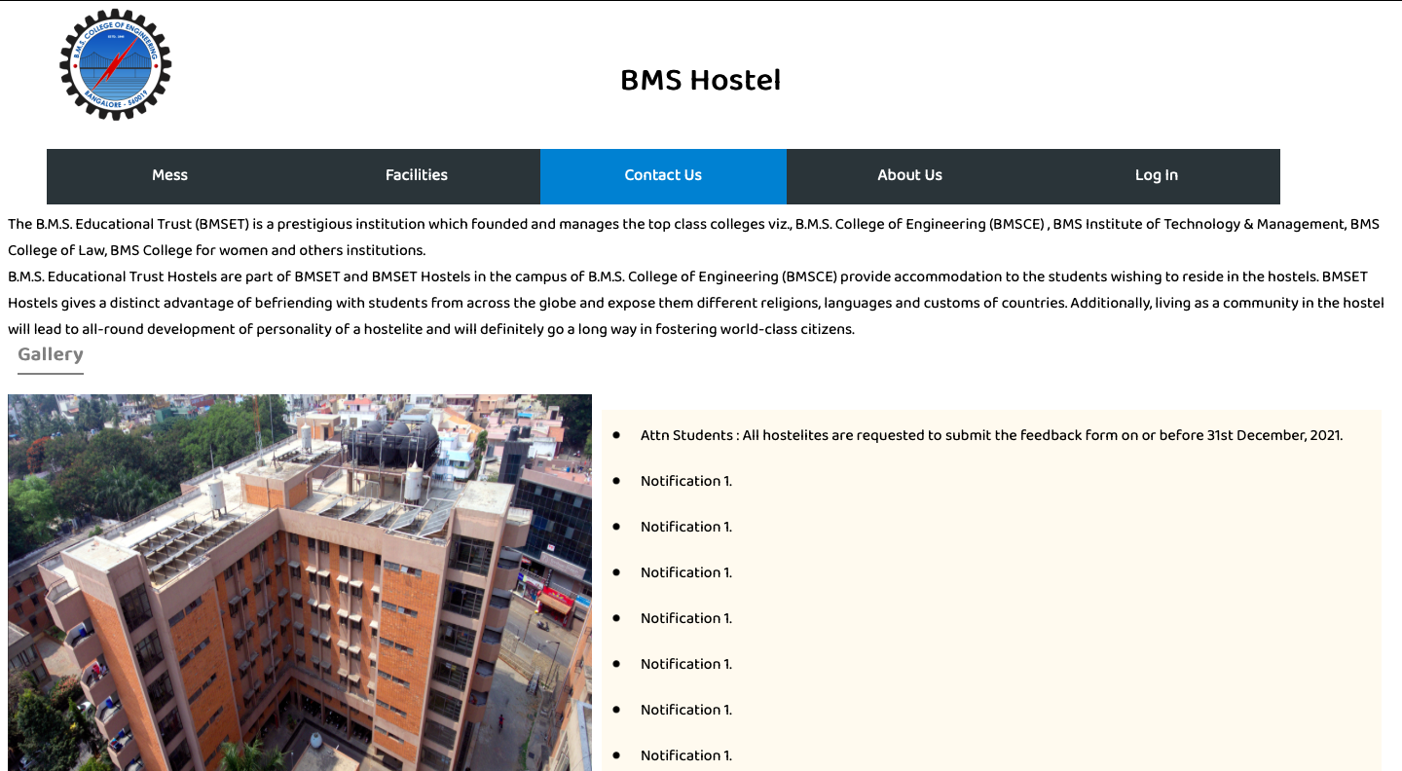

* Mess

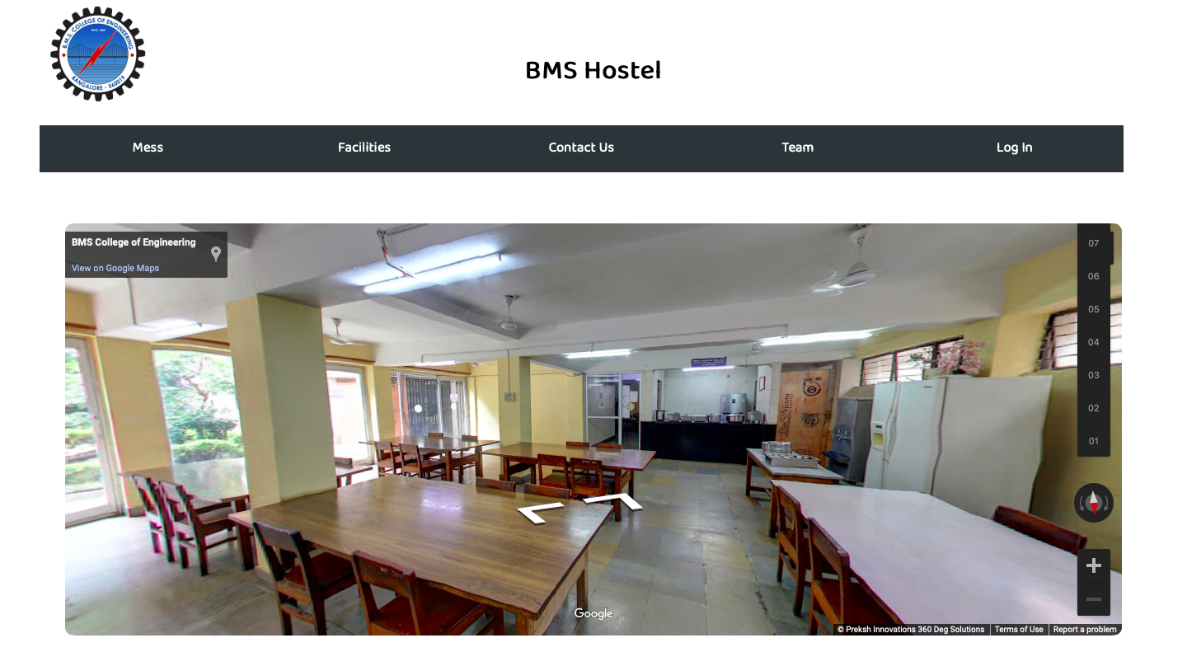There are set timings and rules in the BMS hostel which are all mentioned on our hostel mess page. Every rule and all hostel related queries are cumulated and put together in one place on the hostel website for all-time access to every resident of the campus.

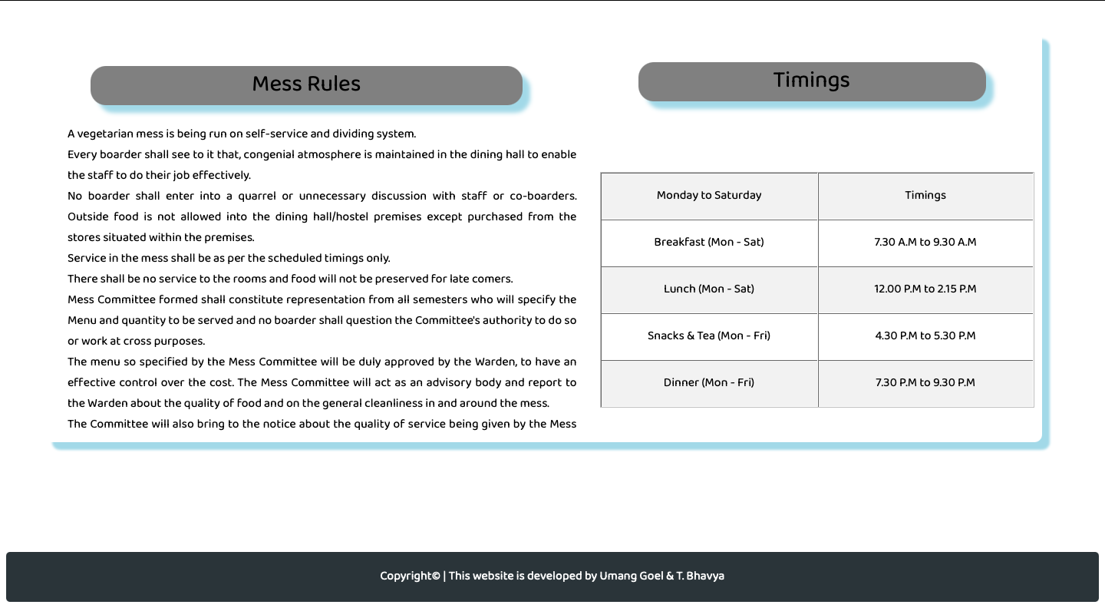

* Facilities

Users can view the facilities that can be availed at the hostel, the basic amenities, timings, types of accommodation and rules and regulations of the hostel.

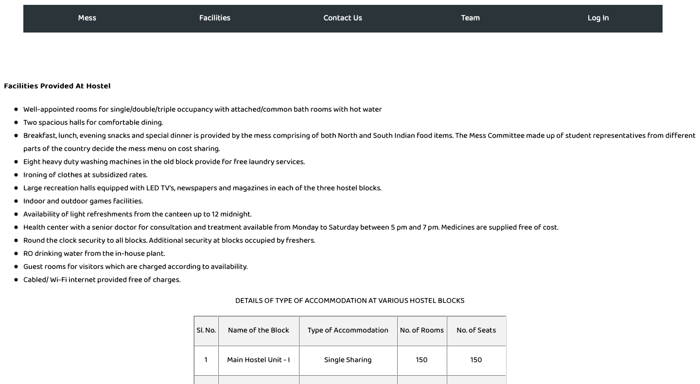

* Contact Us

The user will have the option to submit a form to the BMS Hostels on this page. This page serves the purpose of providing a medium of communication between a new user and the admin/heads of the hostel community.

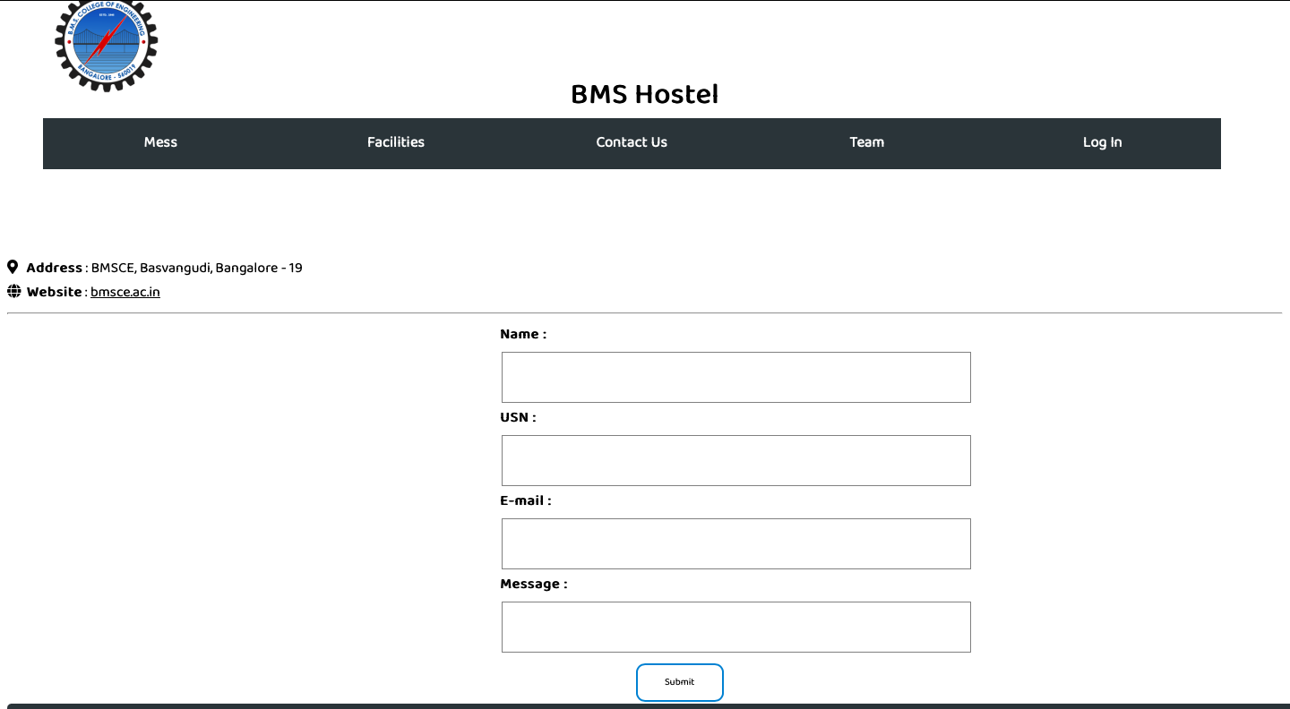

* The Team

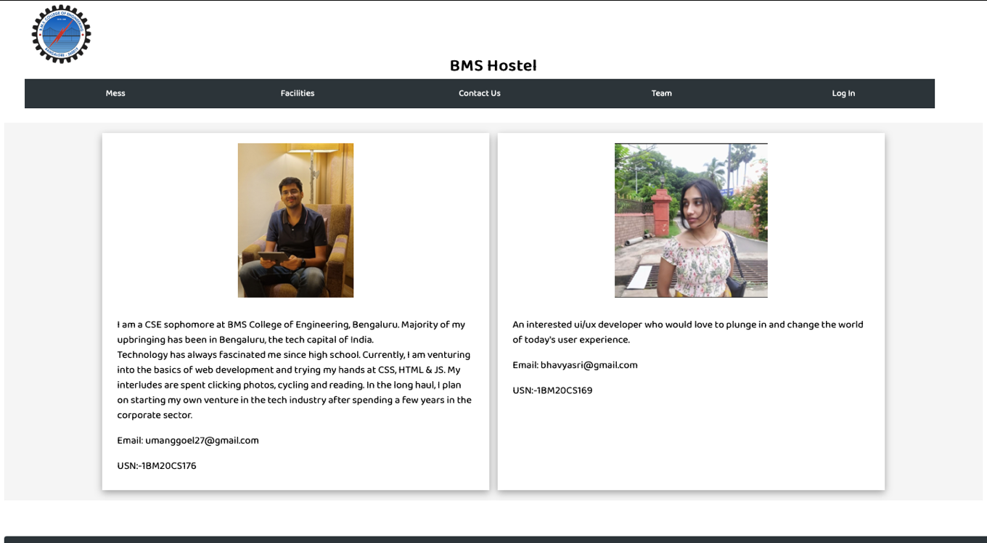

* Log-in page

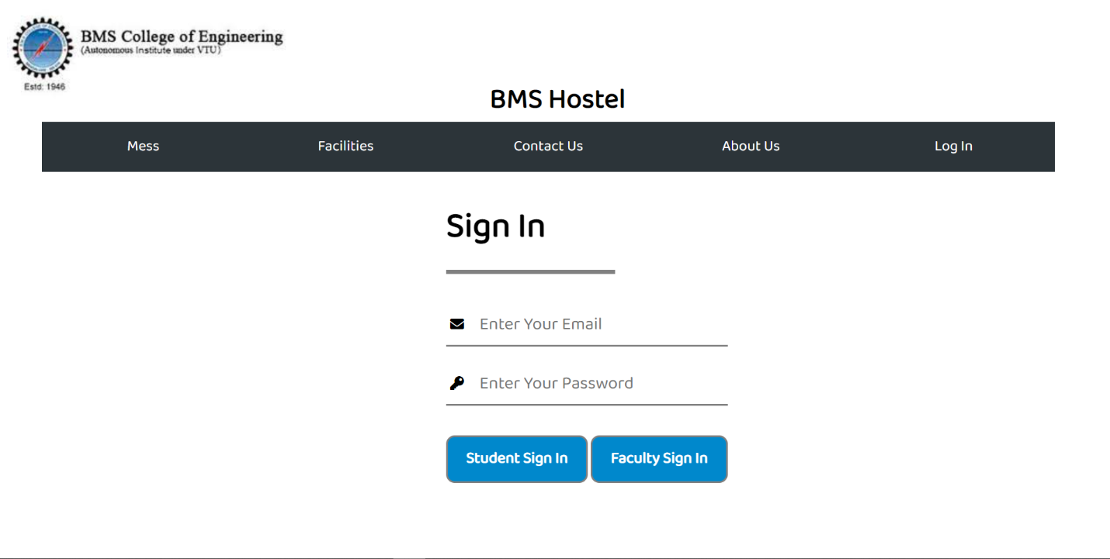

This is the main proposition of our website, i.e, the Log-in page. This page consists of two textboxes for the users to enter their credentials and log-in to their respective hostel portals allotted to all BMSCE residents on admission.

The two Sign-in buttons redirect the user to their respective profiles – the student portal, or faculty portal page.

* Student Portal

1. Profile

The student can view their profile here, their details and find the navigation bar to access the other features of the portal.

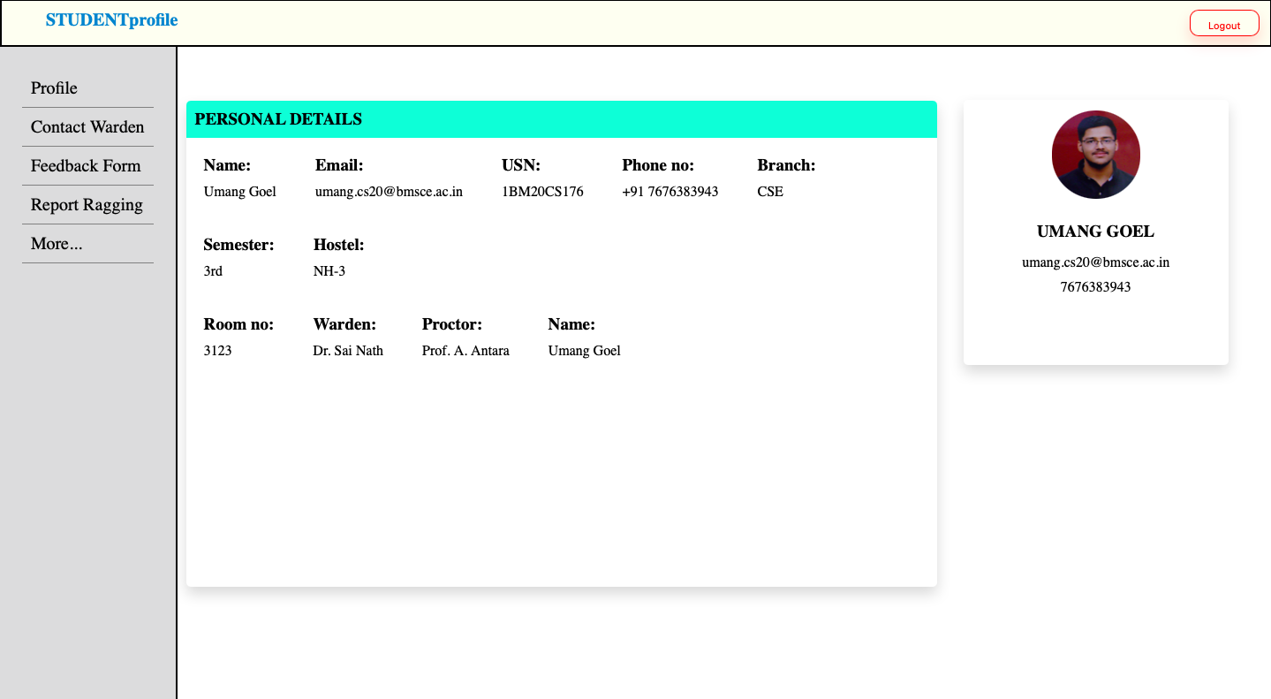

1. Contact Warden

Students can communicate with their wardens from this page.

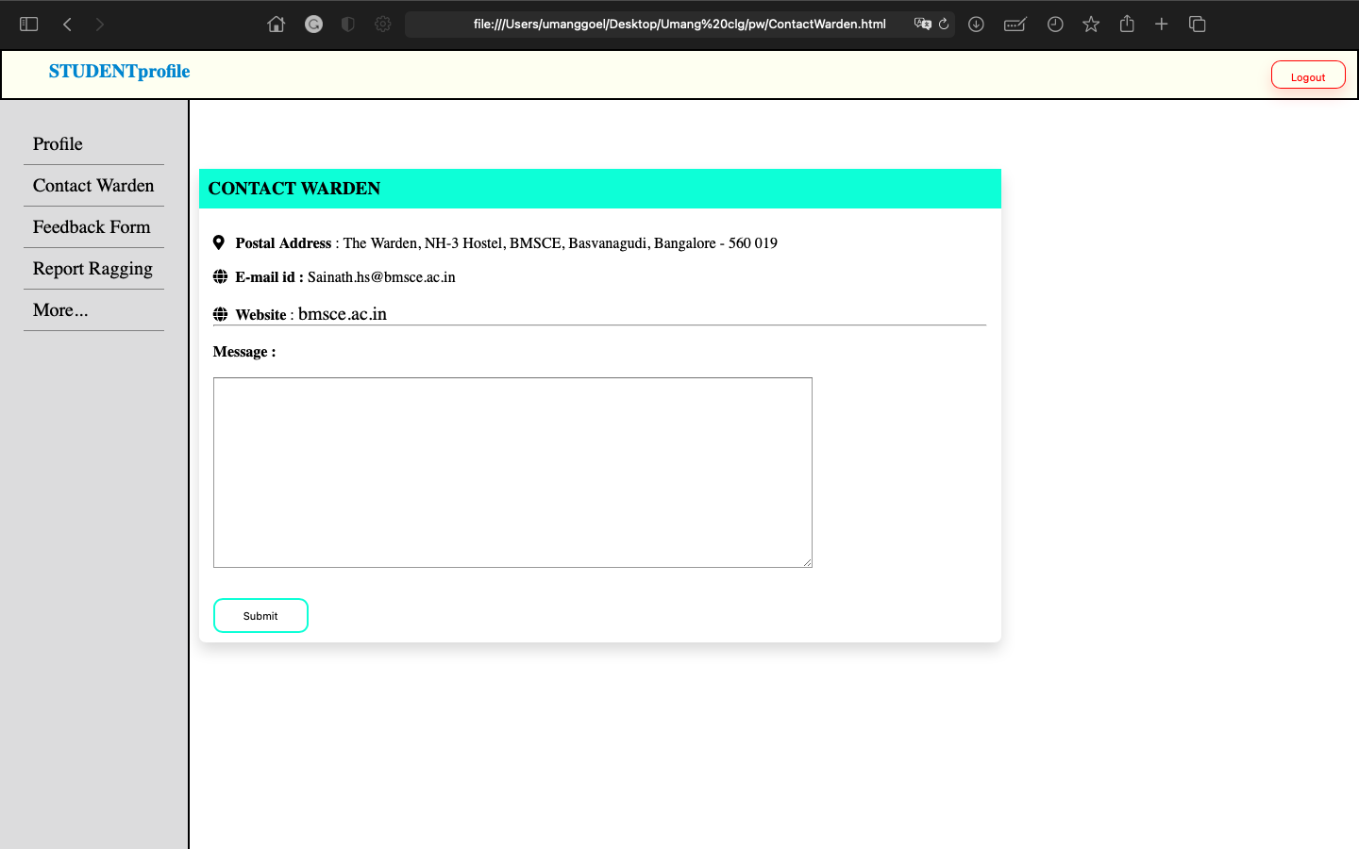

1. Feedback Form

Students can fill in the monthly feedback form uploaded by the administration every month.

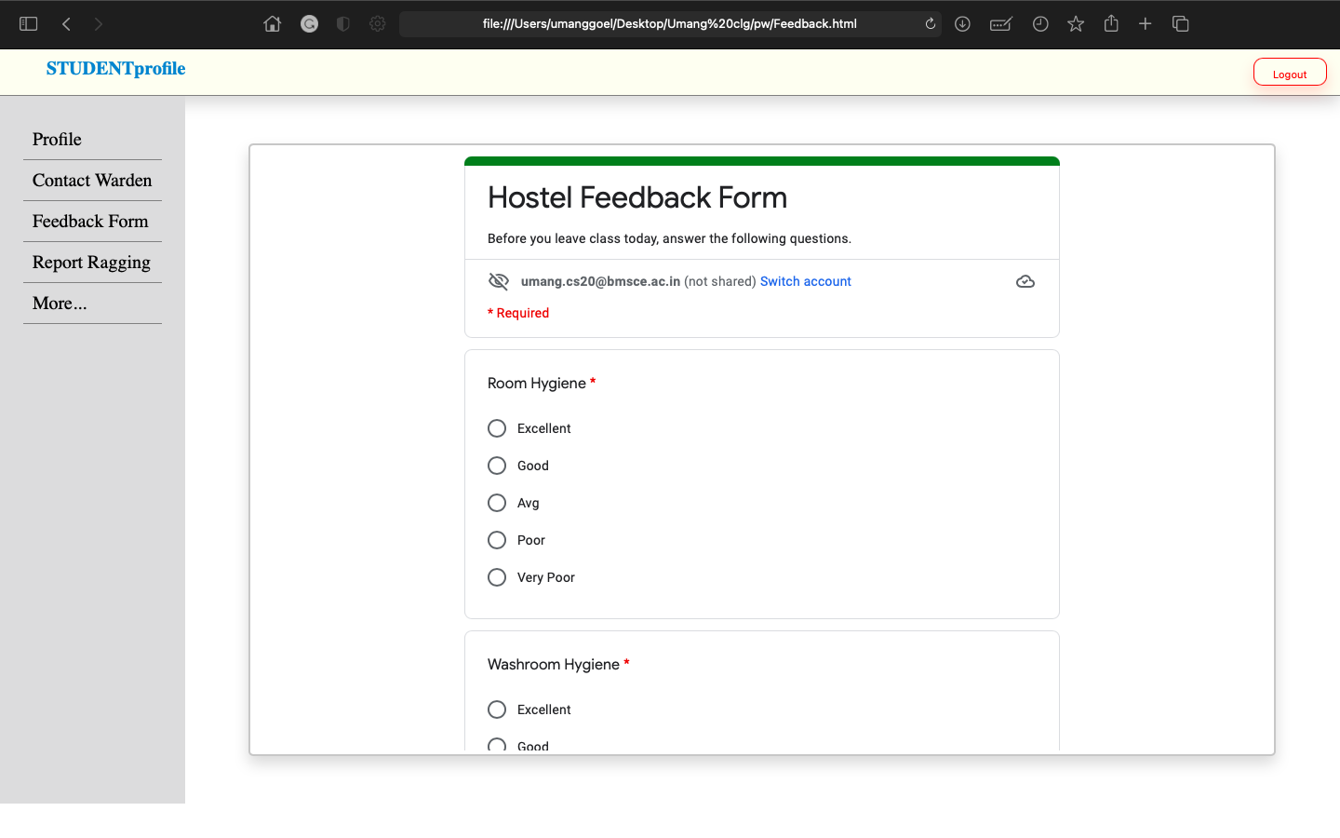

1. Report Ragging

Students can fill in the Report Ragging form and connect with the anti-ragging committee immediately.

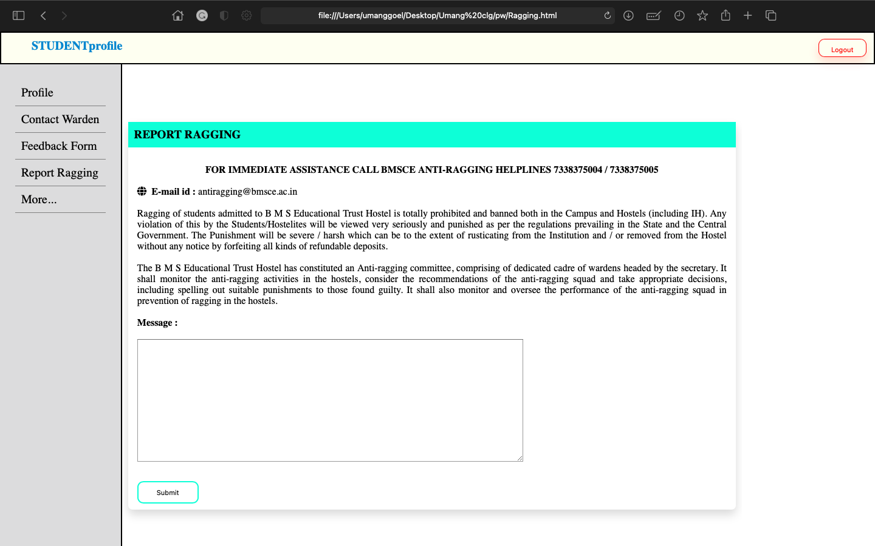

The faculty sign in also redirects the wardens/mentors to their respective mentor portals, identical to the student portal. The faculty members also view a page with some of their general details, along with options to submit a feedback form, apply for a leave, view a list of their students in charge and keep track of their respective workload, along with managing their academic stress.

This page, however, is still in the making and will show up on further enhancement and building of the website.

* PROJECT LAYOUT:

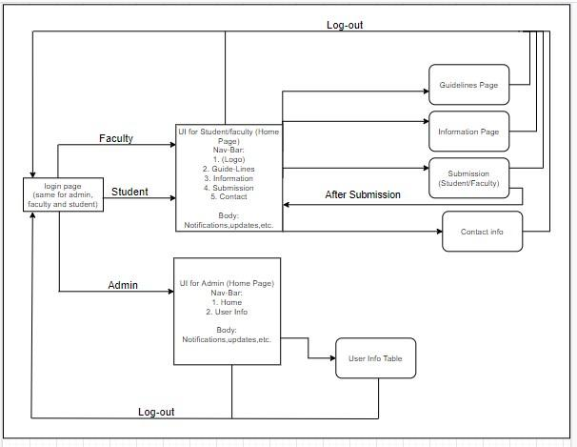

SOURCE CODE LINK:

The following link directs you to the GitHub repository which contain the source code to all of the above-mentioned webpages.

<https://github.com/Bhavya-Tamminana/Project-1>